Oral Health Improvement Team
Armley Moor Health Centre
95 Town Street
Armley
Leeds
LS12 3HD

Tel 0113 843 0387
Fax 0113 843 0391

leeds.smiles@nhs.net

Dear Head Teacher / Principal,

The Oral Health improvement team are commissioned by Leeds City Council to provide oral health services to schools in Leeds.

We offer free resource boxes for use with nursery and primary school children and also provide champion’s training for school staff. This enables staff to delivery key oral health messages in a fun interactive way.

Our team previously ran a delivery and collection of resource boxes to primary schools in line with the National Curriculum where schools could loan a resource box for two weeks. We will be restarting this offer again from September 2017.

We would brief the teachers on up-to-date oral health messages when we deliver a box and also do an evaluation with five children to measure their oral health knowledge before and after use of the resources.

If you would like to book a resource box please contact us via email or phone and we can schedule this in line with your oral health topic.

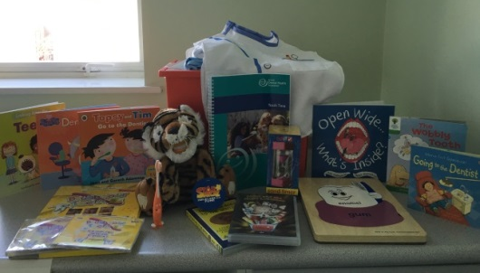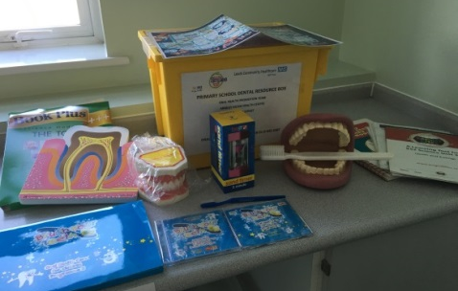

In addition to the above offer we also provide regular champions training for your staff to attend. Please see the attached flyer for further details of what is included in the training and how to book.

Yours sincerely,

The Oral Health Improvement Team

Free Oral Health Champion’s Training

Monday 16th October 2017 1:30pm—4pm
Monday 27th November 2017 9:30am—12pm
Monday 27th November 2017 1:30pm—4pm
Wednesday 24th January 2018 1:30pm—4pm
Wednesday 7th February 2018 9:30am—12pm

At
Armley Moor Health Centre

Key topics which will be discussed include:
- Key oral health messages
- Diet
- Effective tooth brushing
- Update knowledge of the diseases in the mouth
- Visiting the dentist
- Access to fluoride varnish for children
- Maintaining children’s oral health
leeds.smiles@nhs.net
Oral Health Development Team
Armley Moor Health Centre
95 Town Street
Armley
Leeds
LS12 3HD
0113 843 0387
If you are interested in booking onto a training session, please contact us.
SAVE YOUR DATES

