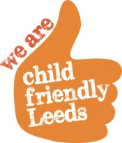
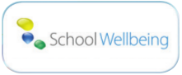

2016/17: My Health My School (Health Behaviour) Survey (MHMSS)

The survey continues to support schools with their Ofsted framework and this year includes questions regarding ‘British Values’, ‘Self-harm’ and ‘Radicalisation/Extremism’. These questions offer additional support for the judgement on ‘Personal development, behaviour and welfare’ and ‘Safeguarding’.

The survey continues to be FREE to all schools and academies in Leeds and in 2015/6 over 9,000 pupils completed the survey.

The survey is completed online, by pupils in years 5, 6, 7, 9 and 11 and includes a Catholic version allowing all schools across the city to get involved. We request that schools plan ahead and engage with their pupils to obtain this vital child health data.

Implementing the survey involves three easy to follow one hour lessons: a preparatory lesson, a lesson using individual computers under exam conditions, and a plenary lesson. It is advised that for validity and reliability, the survey be completed at the same time each year.

Leeds now has 9 years of trend data from the questions in the MHMS Survey. Feedback from schools tells us that new software has allowed high functioning user experience, both for pupils and staff. We would also encourage schools to share relevant data with their school council to spark creative pupil-led action.

To view a school case study or the Leeds city data please go to http://myhealthmyschoolsurvey.org.uk/
To register to complete the survey please go to http://myhealthmyschoolsurvey.org.uk/registration

If you have any queries about the survey please contact: Steve Body on 07891 273134 steven.body@leeds.gov.uk OR Emma Newton on 07891 276623 emma.newton@leeds.gov.uk

