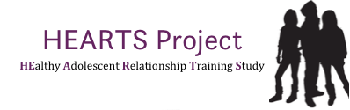

TIMETABLE - what happens when?

Details are to be finalised but broadly the timetable will look as follows:

Autumn term 2015 – before Spring Half-term break 2016
Sep 2015 – Feb 2016 Recruitment and sign-up of schools

Collect active parental consent for pupils to take part in the HEARTS study(supported by schools/teachers)

After Spring Half-term break 2016
Feb – March 2016 1stPupil online questionnaires in all schools for Year 9(supported by schools/ teachers)

Schools randomly allocated to intervention group (delivery in Year 9) and comparison group (delivery either after study completed or in Year 7 or Year 8)

FaceUp training for intervention schools (for teachers of Year 9) and comparison schools (for teachers of Year 7 and 8). IMPORTANT: Teachers that teach PSHE in Year 7 and 8 in the comparison schools need to be different from teachers teaching PSHE in Year 9.

Summer term 2016
Apr – June Intervention schools deliver FaceUp(in full, for the first time) inYear 9; comparison group schools deliver Face Up in Year 7 and Year 8 (with different PSHE teachers than Year 9).

Teachers of Face Up in Year 9 complete short questionnaires after each lesson

End Jun/ Early July 2ndPupil online questionnaires in all schools for Year 9
(supported by schools/ teachers)

Short teacher questionnaire for all schools

Spring Half-term 2017
Jan- March 2017 3rd Pupil online questionnaires in all schools for Year 10 (who were Year 9 in previous school year)

Short teacher questionnaire for all schools

Summer term 2017
July 2017 Results made available

