**School Name: St Margarets**

**Student Voice Influencing Extra Curricular. (Enabling an Inclusive Offer, Increased Participation and City and County final success.)**

**How?**

We invited the children to be a part of the decision making process, by inviting student voice. The children stated what they would like to see on offer, and this helped us to timetable the extra-curricular activities that we were able to provide.

We now offer clubs every day of the week, some before school and some after school.

In addition to this, we have used our participation data to engage our least active children into leadership roles, using change 4 life and Young Leaders -delivered during assembly time.

In order to engage all children in school, we have run clubs for the visually impaired, by the visually impaired.

**HOW?**

**Key Indicator**

**1:** The engagement of all pupils in regular physical activity – Chief Medical Officer Guidelines recommend that primary school children undertake at least 30 minutes of physical activity a day in school

**2:** The profile of PE and sport being raised across the school as a tool for whole school improvement

**3:** Increased confidence, knowledge and skills of all staff in teaching PE and sport

**4:** Broader experience of a range of sports and activities offered to all pupils

**5:** Increased participation in competitive sport

**Why?**

As a school, we were aware that we had a number of children who were not actively participating in physical activity during the school day.

We set ourselves a challenge to engage more children in physical activity, whilst increasing a broader range of activities that we offer to all pupils.

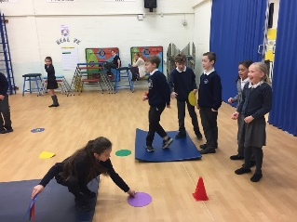

**Quotes**

“At school we have done circuit training to increase my stamina,” Lewis, Year 6

“I love cross country! I even go on extra runs,” Isla, Year 3

“I’m REALLY active in PE,” Lucas, Year 3

“I think Tuesday Milers has helped me with my fitness and my cross country performance and my stamina,” Oliver, Year 5

“Indoor athletics has helped me improve with all my events and it was FUN!!, “ Abi, Year 6

“I do Milers, a running club, Park Run, and I run with my mum”, Danielle, Year 4

“I have done athletic training and have occasionally done the Tuesday Milers. I also think all the help I have had from the amazing staff here have really affected my performance as well as all the Saturday races,” Jacob P, Year 6

Athletics training has made me fitter and improved my lung capacity as well as being fun and adrenaline packed,” Daphne, Year 6

**Pupil’s quotes:**

**IMPACT**

We are engaging more children into our extra-curricular activities, by offering activities that appeal to the children. We are offering clubs every day, some before school and some after school. These include Archery, Milers Club, Gymnastics, Fencing, Tchouckball, American Football and Ultimate Frisbee.

We regularly attend Cross Country races on a Saturday morning, attracting a range of children. We have many children who attend our Morning Milers Club, which has resulted in our best Cross Country Success to date. We are taking 35 children to the West Yorkshire Cross Country Final this year.

As we have many children attending these clubs, and learning new skills, we have also experienced success at the Indoor Athletics Competition, placing third at the Leeds Semi Finals.

As well as improving our performance at city and county level, we also have increased the number of children representing out of school at a participation level. All year groups have had opportunities to compete against other local schools, through the work of our Active Schools Coordinator.

We have targeted our SEND and least active pupils, ensuring that out least active children have had the opportunity to be a sports leader, or to take part in a Change 4 Life Club.

For the first time, we had the Visually Impaired Sports coaches come to run a club for our visually impaired children.

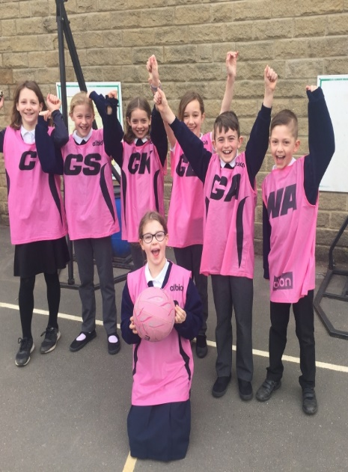[](https://www.google.co.uk/url?sa=i&rct=j&q=&esrc=s&source=images&cd=&cad=rja&uact=8&ved=2ahUKEwjP_-ysoLPeAhUE-qQKHaJoC94QjRx6BAgBEAU&url=https://www.astroexhibitions.co.uk/how-much-does-an-exhibition-stand-cost/&psig=AOvVaw1DFKLUd1deOiWe5BMh3nbC&ust=1541163640140755) 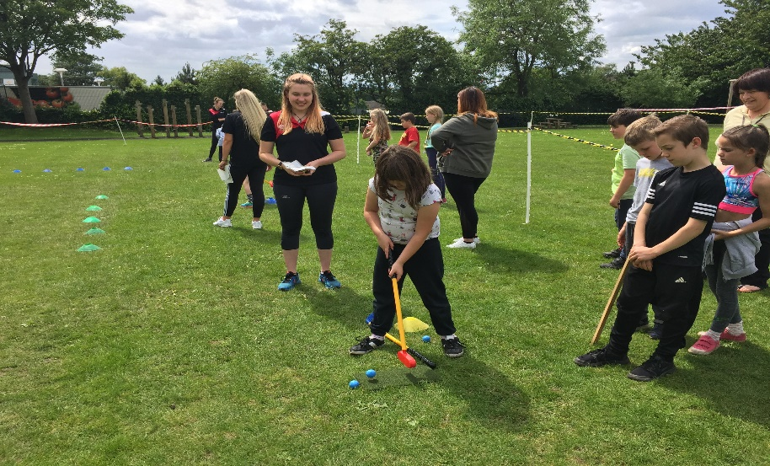

* **Parents come and support children at all the events.**
* **We regularly update our website and school newsletter with sporting news.**
* **Parents can sign children up for events via parentmail**
* **We have introduced REAL play to our Reception parents to encourage physical activity at home.**
* **Reception parents receive a book showcasing what the children have done, this allows the children to share their learning.**
* **Signposting parents towards local clubs via parentmail and the PE board.**
* Parents pay £2 for morning clubs and £4 for after school clubs.
* Many free clubs
* Active school’s coordinator 1 day per week.

**For more information contact:** [**office@stmargarets.leeds.sch.uk**](mailto:office@stmargarets.leeds.sch.uk)

**stmargarets.leeds.sch.uk**

**01133862520**

**NEXT STEPS**

* To ensure that we continue to use pupil voice to improve provision.
* To continue to engage our least active children.
* To promote participation at all levels of School Games.
* To enage all children in at least 30 munites of physical activity every day.

**ENGAGING PARENTS**