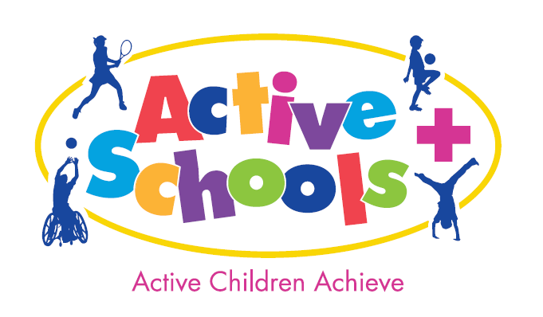

Junior Warrior – Bramham Park, Leeds
Thursday 25th June 2020

Active Schools+ Entry form

Dear PE Subject Leader
I am delighted to invite all Active Schools to join us for Junior Warrior 2020 which was a sell out in 2019. We would like to offer places to 10 of your KS2 pupils and would encourage you to use this as an opportunity to reward your sports/play leaders that have worked so hard across the year.

Places will be allocated on a first come first served basis and schools will be charged @ the cost price of £13 per child should they fail to attend.
(Active Schools have purchased 4 waves to allocate to our schools)

We would like to invite you to bring a group of 10 KS2 children to take on the 3KM route, with 12 obstacles (tailor built for the age range), tackling walls, pipes, nets, loads of mud and an awesome water slide!

By way of background, Total Warrior are a professional events delivery company, putting on obstacle course races (OCRs) across the country since 2011. They are returning to Leeds for the 7^{h} year and expect over 15,000 entrants to take part at Bramham Park over the weekend of 26th – 28th June 2020. In an effort to maintain Total Warrior’s reputation as an epic adventure for all the family, the team don’t want young people stuck on the sidelines; they want to build on the success of Junior Warrior over the past couple of years, and encourage them to get stuck in.

Event Information:

Schools will be issued with wave times for the Thursday afternoon upon receipt of this entry form. (We will email schools with confirmation each Friday)

Each school will be given an arrival time 45 minutes before their wave start time, and it will take the children approximately 45 minutes to complete the course, including a start line briefing. Upon finishing, each child will receive a medal. Once your school has completed the course you will be free to return to school, although there is space for your school to eat a picnic and watch other waves go across the course should you wish.

There are toilets onsite, along with a marquee with split boys and girls changing. I suggest the children change at school and come in the clothes they intend to take part in, with a spare change of clothes, an old towel and a bag to put messy clothes and shoes in for afterwards. There are not showers onsite.

Please note the course involves mud and water. The children will need to bring clothes and shoes that are okay to be returned home muddy. We often retrieve old shoes which young Warriors lose on the course; it’s essential that kids come with schools that they don’t mind getting very muddy, and ensure they are tied as tightly as possible.

All necessary documentation – including the Risk Assessment – will be available to download from Evolve from Tuesday 21st April 2020.

If you have any questions, please don’t hesitate to contact me, and I sincerely hope you’ll be a part of this fantastic opportunity for young people in our Leeds Active Schools family.

Places are limited and will be issued on a first come first served basis.

School Name:
Contact Name:
Email address:
Number of children: | Maximum 10
Year Group(s):

*In order to secure your booking, please return this form to activeschools@leeds.gov.uk with Junior Warrior in the subject box.
I would be most grateful if you could email this back to me as soon as possible.

Yours faithfully,

Donna Russell
Active Schools+

