**Why?**

Last year, the ‘Active Mile’ was introduced, to ensure all children at Robin Hood were taking part in physical activity.

However, the children began to run less and they soon became bored of the concept (survey revealed children’s thoughts); this was resulting in less physical activity.

As a result, we have now introduced the ‘Active 10’ to engage all children in regular physical activity and to meet the CMO’s recommended guided of 30 active minutes per day at school.

**How?**

The ‘Active 10’ is a daily activity which years 1 to 6 complete every afternoon for 10 minutes in their phases.

In each corner of the playground, there is a station –totalling 4 stations for the children to complete.

The children work at each station for 2 and a half minutes, where an activity card shows them the activity, tips on to be successful, muscle groups used and a progression, should the children be finding it too easy.

After 2 and a half minutes, the children rotate clockwise to the next station; they complete all 4 stations in 10 minutes.

In order to keep the children engaged and challenged, the activities vary every day. Some examples of the activities: speed bounce, skipping, burpees, boxing arms, spotty dog, etc.

**Key Indicator**

**1:** The engagement of all pupils in regular physical activity – Chief Medical Officer Guidelines recommend that primary school children undertake at least 30 minutes of physical activity a day in school

**2:** The profile of PE and sport being raised across the school as a tool for whole school improvement

**3:** Increased confidence, knowledge and skills of all staff in teaching PE and sport

**4:** Broader experience of a range of sports and activities offered to all pupils

**5:** Increased participation in competitive sport

**Robin Hood Primary School**  
**Active 10**

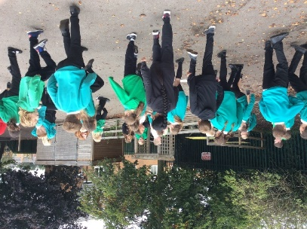

**For more information, contact: Emily Hobson (PE Subject Lead)  
emily.hobson@robinhood.leeds.sch.uk**

**IMPACT:**

* All children’s fitness was baselined at the beginning of the year using the Active Mile. The children’s laps were tracked in 10 minutes and recorded on a whole-school tracker.
* Children collected an elastic band every time they passed the start/finish to track they had run.
* At the end of each term, the children re-do the fitness test to see improvement in their fitness levels.
* Behaviour in the classroom has improved; children are having time away from learning/classroom for 10 minutes.
* Providing children with intense physical activity every day.
* Children are becoming familiar with muscle groups used.
* Staff also involved (well-being link)

**Pupil’s quotes:  
“We get to practise lots of different activities and skills.” Year 6 pupil**

**“I enjoy having a brain break because I can concentrate more in class after!” Year 5 pupil**

**Why?**

Many children through school were not accessing sport and/or activities out school (survey revealed this); most of these children are Pupil Premium.

The aim of the PE Home Learning Bag was to ensure all children at Robin Hood had access to sport and/or activities at home, as well as to promote the outdoors and sport to our children and their families.

**How?**

Each class was provided with a ‘PE Home Learning Bag’ containing an array of sporting equipment: 2 cones, a skipping rope, a quoit, 2 bean bags, a Frisbee, football and a book of activities they could play with the equipment. One child per class is chosen to take the bag home at the weekend (aimed at key children to start with). Children were encouraged to devise a game using the provided equipment and then write about their game/idea in the notebook provided. Children and their families were also encouraged to send pictures of them using the equipment to the school email and/or Twitter account.

**Key Indicator**

**1:** The engagement of all pupils in regular physical activity – Chief Medical Officer Guidelines recommend that primary school children undertake at least 30 minutes of physical activity a day in school

**2:** The profile of PE and sport being raised across the school as a tool for whole school improvement

**3:** Increased confidence, knowledge and skills of all staff in teaching PE and sport

**4:** Broader experience of a range of sports and activities offered to all pupils

**5:** Increased participation in competitive sport

**Robin Hood Primary School**  
**PE Home Learning Bag**

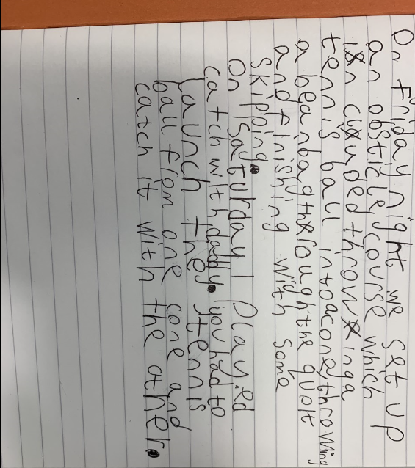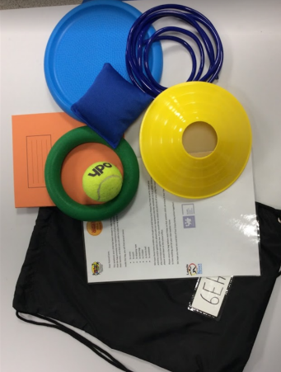

**IMPACT:**

* Whole-school involved in out of school sport and activities.
* Not just impacting our children, put their families too: promoting sport and activity.
* Engaging children with physical activity out of school (30:30)
* ‘Inactive children’ participating in sport

**For more information, contact: Emily Hobson (PE Subject Lead)  
emily.hobson@robinhood.leeds.sch.uk**

**Teacher’s quote:  
Year 2 Teacher: “The Homework bags are allowing my inactive children to enjoy being active through quality family time.”**

**Robin Hood Primary School**  
**Drop It and Move!**

**Why?**

Completed heat mats through school showed many cold areas during school time, unless it was the Active 10, break time, lunch time or after school. As well as making lessons more active and provided ideas around this, we introduced a through school idea: ’Drop it and Move!’ to promote regular physical activity for all children in our school.

**How?**

During lessons, if ‘Drop it and Move’ is called, all children stop what they are doing, stand behind their chair and get ready for a 2-minute burst of activity.

A lollipop stick is chosen at random which shows an activity which can be completed behind their chair or by moving around the classroom sensibly and calmly.

Activities include an array of options: ‘Race your partner’, ‘Freestyle dance’, ‘Rock, Paper, Scissors’, ‘Spotty Dog’ etc.

**Key Indicator**

**1:** The engagement of all pupils in regular physical activity – Chief Medical Officer Guidelines recommend that primary school children undertake at least 30 minutes of physical activity a day in school

**2:** The profile of PE and sport being raised across the school as a tool for whole school improvement

**3:** Increased confidence, knowledge and skills of all staff in teaching PE and sport

**4:** Broader experience of a range of sports and activities offered to all pupils

**5:** Increased participation in competitive sport

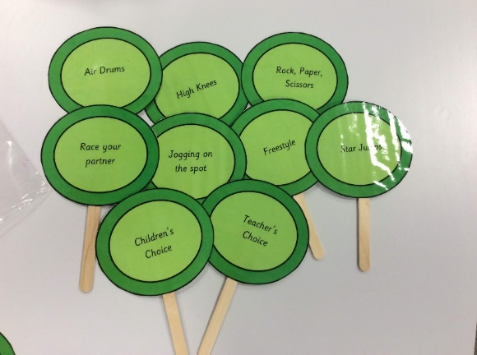

**For more information, contact: Emily Hobson (PE Subject Lead)  
emily.hobson@robinhood.leeds.sch.uk**

**Pupil’s quotes:**

**“I wait for Drop it and Move to be called because I love it!” Year 6 Pupil**

**“My favourite is Rock, Paper, Scissors; we get to move around the classroom.”**

**Teacher’s quote:**

**“It allows my pupils to be active and have a break. They concentrate much more.”**

**IMPACT:**

* Whole-school involved in physical activity every lesson (30:30)
* Improving fitness levels, along with stamina, of all children at Robin Hood
* Promoting the importance of physical activity
* Enjoyment!! Feedback from children was been really positive.
* Improved behaviour in lessons due to ‘brain breaks’

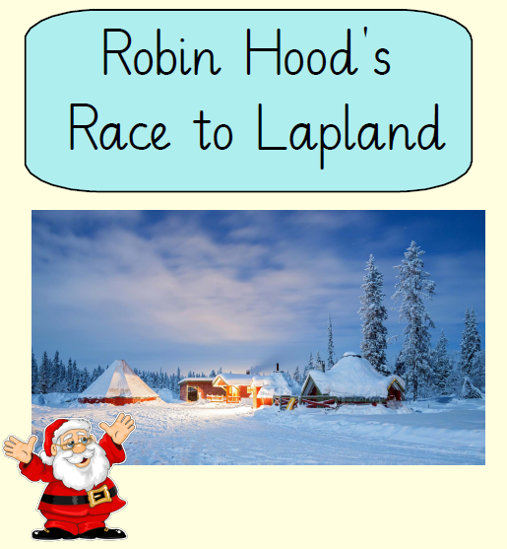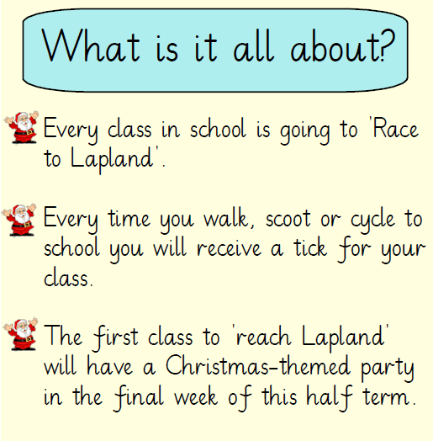

**IMPACT:**

* Whole-school involved in physical activity every lesson of the day (30:30)
* More children walking/scooting/cycling to school
* Towards our Travel School (Healthy Schools) award
* Competition element
* Families involved in physical activity.
* Improving fitness levels of Robin Hood children
* Promoting the importance of being active and staying healthy
* Pupil engagement and enjoyment

**Pupil’s quotes:**

**“We received 150 ticks in just 3 days! We want to win!” Year 3 Pupil**

**“I love cycling to school because it makes me feel happy!” Year 2 Pupil**

**How?**

Every class was entered into the competition: ‘Race to Lapland’. Every time a child walked, scootered and cycled they were awarded a tick for their class chart. As Lapland is approximately 1,000 miles away, ach tick was worth 2 miles; this meant the winning class needed to achieve 500 ticks on their chart. Once this had been achieved, the winning class was awarded a Christmas-themed party.

**Why?**

As part of our School Travel Plan to achieve our Bronze Award, we promoted children travelling to school by walking, scooting or cycling. A whole-school assembly was held to promote the event and the event was also promoted on the whole-school newsletter. This innovate was also used as an example of good practice in the ‘Leeds Travel to School Newsletter’

**For more information, contact: Emily Hobson (PE Subject Lead)  
emily.hobson@robinhood.leeds.sch.uk**

**Robin Hood Primary School**  
**Race to Lapland**

**Key Indicator**

**1:** The engagement of all pupils in regular physical activity – Chief Medical Officer Guidelines recommend that primary school children undertake at least 30 minutes of physical activity a day in school

**2:** The profile of PE and sport being raised across the school as a tool for whole school improvement

**3:** Increased confidence, knowledge and skills of all staff in teaching PE and sport

**4:** Broader experience of a range of sports and activities offered to all pupils

**5:** Increased participation in competitive sport