**WHY?**

**Children need to be more active during school time. Due to the pressure of targets and learning sitting down is a key factor of each pupil’s day. The reason for Active Maths is to give children more exercise throughout the day and restore a love for learning.**

**HOW?**

**Across KS1 and KS2 children at Middleton St Marys have been taking part in Active Maths lessons. This involves children working together in teams and also as individuals to complete maths questions based on the learning of each week.**

**Children are stood instead of sat, and all children must complete exercises in order to be able to answer questions.**

**Key Indicator**

**1:** The engagement of all pupils in regular physical activity – Chief Medical Officer Guidelines recommend that primary school children undertake at least 30 minutes of physical activity a day in school

**2:** The profile of PE and sport being raised across the school as a tool for whole school improvement

**3:** Increased confidence, knowledge and skills of all staff in teaching PE and sport

**4:** Broader experience of a range of sports and activities offered to all pupils

**5:** Increased participation in competitive sport

School Name: Middleton St Mary’s

Active Classrooms -2018-2019



**Pupil’s quotes:**

**“Active maths is fun and keeps me healthy!”**

**“I enjoy active maths because all week normal maths lessons build up to an exciting fun day!”**

**IMPACT**

**Based on the current year 4 in school maths results have improved. Arithmetic skills are quicker and 71% of children reached the expected standard on the final arithmetic test. The class target was 63%. By increasing the levels of activity and playing Active Maths pupils across school are engaged in all maths lessons throughout the week or unit of work as they want to know answers for Active Maths lessons. Without realising, children have increased their arithmetic speed, resilience and also their love for learning and Active Maths has played a huge part in this.**

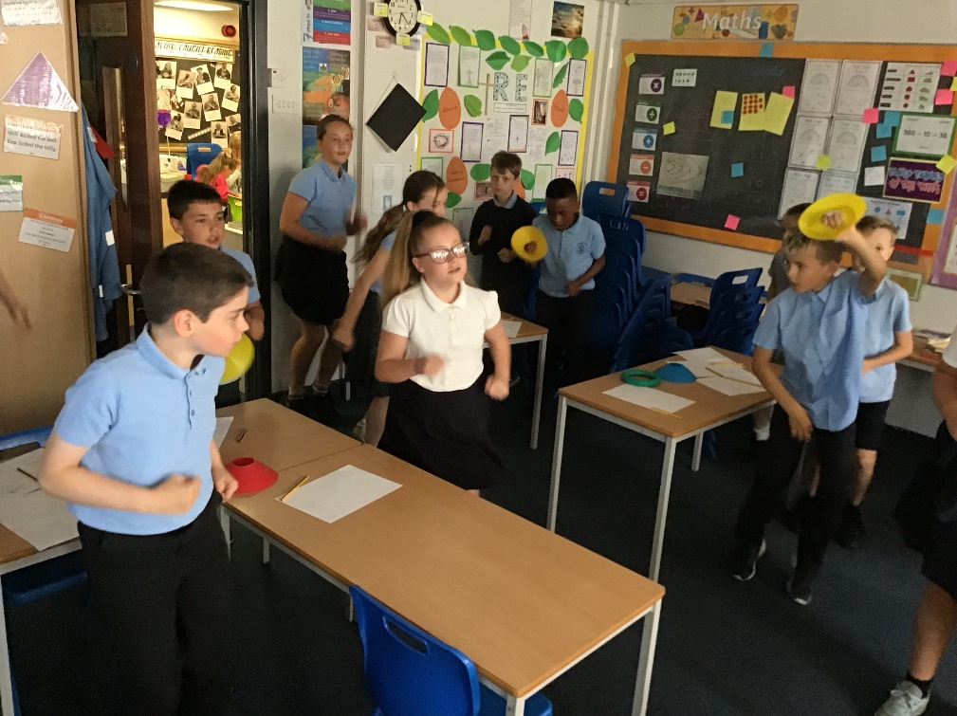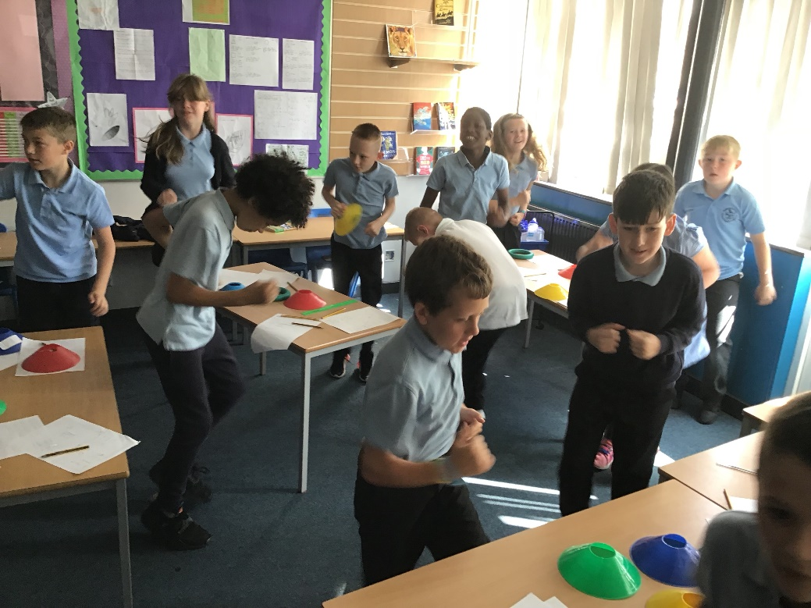

**For more information contact:**

**Dawn Kellett: dawn.kellett@msmleeds.co.uk**

**Nathan Robinson: nathan.robinson@msmleeds.co.uk**

**NEXT STEPS**

**Active Maths at Middleton St Marys has only just begun and there is much more room for development.**

**Each class has a slightly different way of performing this and moving forward more structure is needed to keep active maths getting the results the school needs.**

**Including parents is also something that will be improved on the Active Maths journey.**