September 2019

Dear PE Subject Leader,

Active Schools+ ‘Exploring the outdoors’ Event

at West Leeds Activity Centre for years 5 / 6

21st and 23rd October 2019

I am delighted to invite your school to take part in an outdoor activity afternoon at West Leeds Activity Centre. This is a fun, action packed event giving pupils the opportunity to experience a range of team building activities in an outdoor setting at the West Leeds Activity Centre.

5 activities that are on offer on the day:
- Bush craft -fire lighting
- Orienteering
- Night line
- Team building game
- Mini beasts den building
Each activity is a 30 minute session, where the group will get to explore the outdoors at an amazing location (in the middle of Leeds), also look at working together and commutating with each other.

You are invited to bring up to 10 students and as many adults as you like
Event | Date | Time | Venue | Deadline for Entry
Active Schools+ ‘exploring the outdoors’ at west Leeds activity center | 21st and 23rd Oct 2019 | Arrive 1.45pm  Start 2pm  Finish 4.30pm | West Leeds activity Center,  Lenhurst Ave, Leeds  LS12 2RE | 7th October 2019

If you would like to take part at the session, please indicate which option you would like to attend on the return slip with this letter.

If you wish to register, please return the attached application form as soon as possible – referring to deadlines set above, so that arrangements can be made. However places will be limited & allocated on a first come, first serve basis. Once I have your registration form, I can then confirm your place.

Regards
Hannah Smith

Active Schools / Leeds North East and East School Sport Partnership
Email: Hannah.Smith@leeds.gov.uk
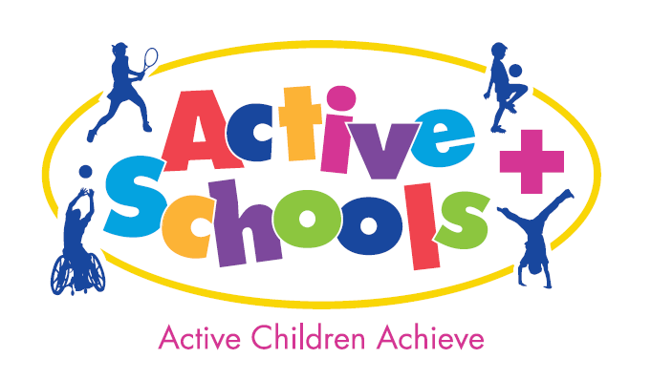

Active schools

Exploring the Outdoors Activity Day for Years 5 / 6
@ West Leeds Activity Centre
21st and 23rd October 2019

School: ……………………………….

Teacher in charge: …….……………….
Email…………………………………………….

Please complete all sections in the table below:

Event | Venue | Option 1  21st Oct  (please tick appropriate) | Option 2  23rd Oct  (please tick appropriate)
‘Exploring the outdoors’ | West Leeds Activity Centre

Spaces will be allocated on a first come, first serve basis.

Please return to;
Hannah.Smith@leeds.gov.uk

HEALTH & SAFETY / SAFEGUARDING
First Aid
Staff are responsible for providing first aid to the children they have brought to the event. Please ensure you bring sufficient first aid supplies.
RISK ASSESSMENTS / EVOLVE NOTIFICATION
It is the responsibility of individual schools to have appropriate risk assessments in place for all activities they attend. SGO’s and Active Schools will not send risk assessments direct to Schools. They should download sample risk assessments from Evolve for all Active Schools and SSP events and personalise them.
For this event risk assessments are under the PE tab on Evolve. The ‘Events’ risk assessment can be adapted to cover the vast majority of sites used, and for all multi skills activities. Your school may also add activity specific risk assessments if they feel it necessary. (Sample activity risk assessments can also be downloaded from Evolve). As always a Transport risk assessment will be required.
FILMING & PHOTOGRAPHY
- The school must have written consent from the parent/carer of all children and young people attending today’s event for images to be taken. Those children and young people for whom the school does not have written consent please inform the organiser.
- Images taken today may be used for publicity purposes or be published in the media or on the internet. These images will be retained for further use, stored on the Leeds City Council server, accessible to the Active Schools+ and School Games Team. On request schools contained in the images may be sent the photograph.
- At major events it may not be possible to control spectators taking photographs. Therefore, we advise that schools advise their parents/carers not to take any photographs/images in order to manage and respect the wishes of those that may not give their consent for the use of photographs. If parents then choose not to follow this guidance and proceed to take photographs that may contain children other than their own child the responsibility is then on the parent.
- Schools should ensure that a designated member of staff for photography has been allocated; only photographs taken by this person can be used by the school for publicity purposes or be published in the media or on the internet.
- The data will be retained for the purpose of sharing images with participating Leeds schools, Active Schools+ and relevant council persons. The data will be retained securely and deleted securely once the data is no longer required.

