**Immaculate Heart of Mary:**

**Daily Mile Spring 2018**

**HOW?**

Premier Sport were invited into school to baseline children’s fitness levels through a standard running activity. Each class teacher was presented with a report detailing individuals and the class as a whole. These were discussed in class and children set themselves targets for the following term, each class produced a class target based on distance or completion rate. In KS2 children were encouraged to set themselves individual targets also.

Class targets were displayed in the sports hall.

Each class began their journey on The Daily Mile, running/ skipping/ dribbling a ball for 15 minutes continuously each day they were not participating in a PE lesson. (3x per week)

A target group in Year 4 were identified as only 22% were able to sustain 4 minutes of running. An extracurricular multi skills club was put on for them, funded by Sport Premium money.

**Key Indicator**

**1:** The engagement of all pupils in regular physical activity – Chief Medical Officer Guidelines recommend that primary school children undertake at least 30 minutes of physical activity a day in school

**2:** The profile of PE and sport being raised across the school as a tool for whole school improvement

**3:** Increased confidence, knowledge and skills of all staff in teaching PE and sport

**4:** Broader experience of a range of sports and activities offered to all pupils

**5:** Increased participation in competitive sport

**WHY?**

Staff reported a growing number of children who struggled to maintain moderate to vigorous activity levels over the course of PE sessions. Children out of breath, disengaging with PE as a result of poor fitness levels.

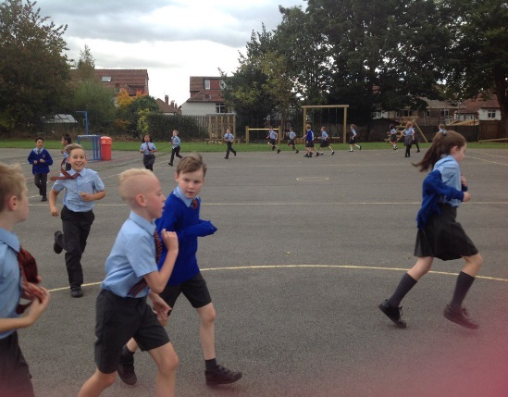

**Year 6 pupil quote:**

**(Before)** I had to run for 4 minutes and I didn't want to. Running is hard for me. I kind of sprinted at the start but I couldn't keep going. It was a bit annoying because my friend Archie could do it.

**(After)** The second time we had to do it I knew that I had to pace myself. Mrs Kent showed us how to keep going at a better pace. I ran for the whole 4 minutes and I didn't give up because I felt more determined. It helped to have people run with me. I was really shocked because I've never really liked stuff like that and I don't run much. I felt really proud of myself and I got 4 merits.

**IMPACT**

When reassessed every class had made a considerable improvement in their outcomes. Both in terms of completion rates and distances covered. The target Yr 4 cohort: An increase from 22% to 90% completion of 4 minutes sustained activity.

In addition to our Year 5 and 6 cross country team, we had enough children interested in Yr 4 to enter a team into the LSSA competitions.

The children took ownership of their targets and encouraged each other to meet them.

The Daily Mile has been extremely successful, not only in increasing the time children spend in being physically active but also in nurturing values such as resilience and determination. School values and ethos are complemented by the values learnt through participation in Physical Activity.

**Immaculate Heart of Mary:**

**Daily Mile Aut 2018**

**For more information contact:**

**Catherine.kent@ihomcps.co.uk**

[](https://www.google.co.uk/url?sa=i&rct=j&q=&esrc=s&source=images&cd=&cad=rja&uact=8&ved=2ahUKEwjP_-ysoLPeAhUE-qQKHaJoC94QjRx6BAgBEAU&url=https://www.astroexhibitions.co.uk/how-much-does-an-exhibition-stand-cost/&psig=AOvVaw1DFKLUd1deOiWe5BMh3nbC&ust=1541163640140755)[](https://www.google.co.uk/url?sa=i&rct=j&q=&esrc=s&source=images&cd=&cad=rja&uact=8&ved=2ahUKEwi97J_Yn7PeAhV1wAIHHcsIBeMQjRx6BAgBEAU&url=https://www.quirks.com/articles/top-5-barriers-to-diversity-and-inclusion-in-your-organization&psig=AOvVaw2P40zDw3f_KYPYVsIfzv94&ust=1541163484594395)

Parents are invited to join their children for Saturday morning cross country sessions. Led by parents. They are also encouraged to participate **WITH** their children in the NE Leeds family fun run at Roundhay Park. Parents are also signposted to local running clubs for beginner sessions and sessions for experienced runners.

£450 tracking children’s progression – Premier Sport

£285 Leader in Running Fitness course – Parent that trains cross country children on a Saturday.

**ENGAGING PARENTS**

**BARRIERS**

**‘Not all children like running’**

They don’t have to run, they can skip, dribble a ball, move like an animal anything goes as long as they are moving and getting out of breath!

**‘How do I fit it into an already packed timetable?’**

Be flexible, do the activity when you can. Mid lesson when things are not going to plan, when concentration levels have dipped, or as part of your lesson – thinking time, walk and talk!

**‘Staff won’t like it!’**

Change is hard, we found that staff who gave it a go expressed positive benefits on their own feelings of wellbeing. Some even bought fitbits and tracked their own activity levels.

**NEXT STEPS**

Termly assessments will help the children to see their progress and set their own targets.

For children in Year 5 and 6 they should be encouraged to set personal targets and to make reflections on their SEMH through participation in the Daily Mile.

Continued intervention/provision for those children identified through assessments.

Use of sport premium money to fund this intervention.

Continued CPD support for staff to ensure that they engage the children through fun delivery and shared target setting.

