**WHY?**

**1. Staff found more and more that reception children lacked the fine motor skills to assist them with simple tasks like dressing and holding a knife and fork.**

**2. Gross motor skills involved with sitting or balancing were also poor.**

3. Social skills of cooperation sharing and turn taking needed to be developed. We wanted children to learn how to co-operate with each other and how to work successfully as part of a group.

4. Senior leadership team are committed to promoting fitness and healthy choices amongst staff as well as children.

**HOW?**

A funding bid was co-written and submitted to National Lottery A4A and won, this was awarded directly to Kidnetics who then deliver to school.

Once a week for 1 hour with reception children. Staff attend the sessions and team teach when they feel ready. Session plans are left with the school to adapt and use outside of planned sessions. This is the 3rd year of delivery.

Equipment has been bought to replicate sessions and is used in outdoor provision area with supervision using the Sport Premium spend.

Kidnetics also deliver 1 staff Zumba session a week (paid for out of school budget) School committing to Health and wellbeing for the whole school community. Staff from another local school - Robin Hood, attend too.

**Key Indicator**

**1:** The engagement of all pupils in regular physical activity – Chief Medical Officer Guidelines recommend that primary school children undertake at least 30 minutes of physical activity a day in school

**2:** The profile of PE and sport being raised across the school as a tool for whole school improvement

**3:** Increased confidence, knowledge and skills of all staff in teaching PE and sport

**4:** Broader experience of a range of sports and activities offered to all pupils

**5:** Increased participation in competitive sport

Thorpe Primary School

Kidnetics – Early Years intervention.



**IMPACT**

Those children in yr 1 &2 that have had Kidnetics input in Reception display better co-ordination, control and ability in games sessions than children in previous cohorts. They listen to and respond well to instruction. A nursery nurse who works across the classes in KS1 and the Early Years has noticed an increased ability in children’s independence in sessions and their ability to follow instructions not only in the PE sessions but in other movement activities in the areas of provision. Staff in the Early years unit have also commented on the way in which children now share and pass around items of equipment in the outside area, such as a passing a ball between friends and taking turns on the climbing equipment. The session is split with half the class attending at a time, 2x30 minutes. This has had multiple benefits: the children in the session have been challenged to meet their needs as the group is small and having a smaller adult to child ratio has allowed for development of language and communication skills. In addition the group that remain in the classroom have flourished in their phonics due to the small group. 56 of these children now attend after school sports/ physical activity clubs - ACE/ Cheer/ Go Noodle. Children in Reception are used to the ‘changing time’ rules of the Kidnetics sessions, ensuring that they dress themselves quickly using only the space in their hoop. At the end of autumn term two, these children could change themselves and store their clothes neatly into a pile in their bags in six minutes. Children achieving ARE + in PE improved for the cohort of children tracked from rec-2015-2016 86% to the same cohort reaching 93% in yr 1 -2016/2017. This dropped slightly to 90% when these children were in Year 2. Results we are proud of nevertheless.

**Pupil’s quotes:**

E (Rec) “It’s fun because we learn how to play games.”

A (Rec) I like Wednesday PE because when we play the games I run faster. I can run faster than the others in my class.”

L (Rec) “I like Dr Dodgeball, you have to throw the ball and if the other person is off the mat then you get a point.”

A: “It makes me happy playing games.”

E.” Everyone should get to do it because it’s fun.”

[](https://www.google.co.uk/url?sa=i&rct=j&q=&esrc=s&source=images&cd=&cad=rja&uact=8&ved=2ahUKEwjP_-ysoLPeAhUE-qQKHaJoC94QjRx6BAgBEAU&url=https://www.astroexhibitions.co.uk/how-much-does-an-exhibition-stand-cost/&psig=AOvVaw1DFKLUd1deOiWe5BMh3nbC&ust=1541163640140755) 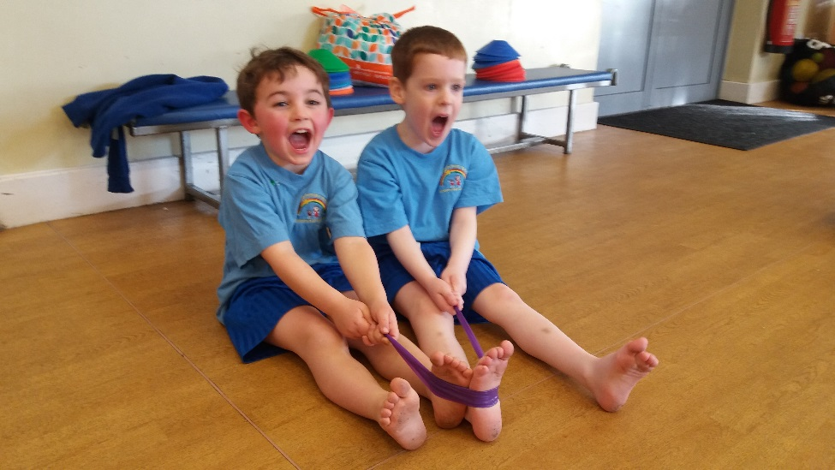

**Engaging Parents**

Parents are aware of the sessions and development through Tapestry reporting for Rec children. Sarah Smith, a KS1 parent at the school said that her son always has lots to tell her about his PE sessions on a Wednesday. Sarah Hobson, another parent said she was really pleased that her daughter could take part in exciting externally provided activities in the school and that it wasn’t just for the older children.

Without Funding sessions cost £35 per hour and plans are left with the school.

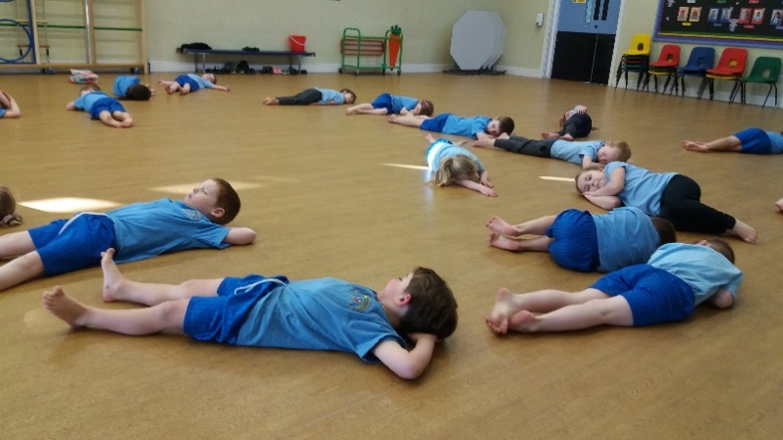

Kidnetics is a fun action packed, high intensity program which develops the fundamental ABC’s (agility, balance and coordination) of a child’s development through games, song and dance and the use of age appropriate equipment.

**For more information contact:**

Courtenay Cowperthwaite

KS2 Phase Leader

**Total Sporting Solutions - MY Community Foundation** [www.tsssport.com](http://www.tsssport.com/)

[www.tsssport.com](http://www.tsssport.com/)

**NEXT STEPS**

The PE subject leader is investigating a Kidnetics programme specifically designed for children with SEND. 6 children in Yr 1 would benefit from this.

Identify other children that would benefit and timetable for this.

Team teaching to continue throughout the year.