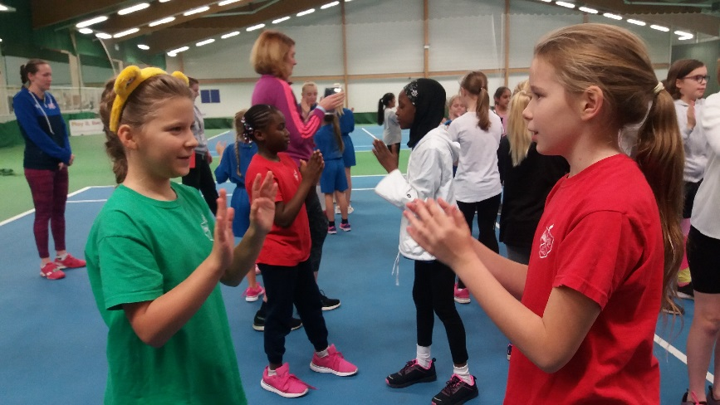

**She Rallies Event**

**JCCS -16th November**

**2018**

CYPP priority 8

Encourage physical activity and healthy eating

**10 schools from across the city, 17 female teachers** and a total of **96** **KS2 girls** took to John Charles Tennis centre for a joint CPD and fun tennis themed festival.

She Rallies: Our goal is to empower and expand the number of women and girls coaching and playing tennis across the UK.

Louise and Angela from the Lawn Tennis Association along with a team of coaching volunteers led the way for what proved to be a highly successful event.

Female staff were expertly coached for the afternoon and are now She Rallies activators armed with the skills and knowledge to lead tennis in their schools.

Through completion of the training they now have login access to the She Rallies activator pages where they can access videos and session plans.

They will also receive a She Rallies equipment pack worth £500 for use in their school.

The children who were a mix of active and inactive worked their way around a series of fun skill building activities and games.

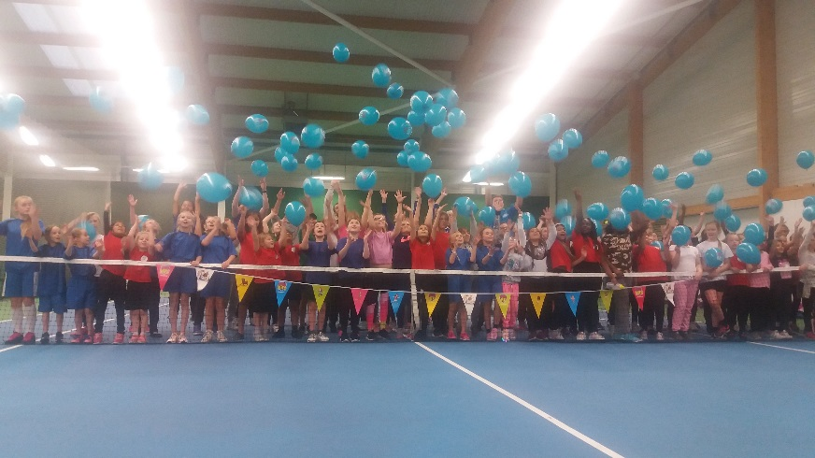

**Quotes from teachers and coaches:**

‘Your enthusiasm and energy was great.’ **Coach**

‘The ideas are so simple and so effective, I would have never thought about doing that myself’ **Teacher**

‘It’s been great to be involved with training while my girls are having fun.’ **Teacher**

‘We sent other staff on this training before, now we have more that want to be involved ‘**Teacher**

