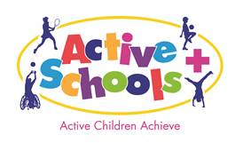

**Early Years Explorer Event**

**Herd Farm -1st and 4th October**

**2018**

CYPP priority 8

Encourage physical activity and healthy eating

**9 schools** and a total of **95** **Reception children** took to Herd Farm for our first Early Years event with Active Schools+.

Through storytelling and role play the children embarked on an adventure to discover clues and find a missing teddy.

They were encouraged to run, jump and climb in a safe environment and to discuss the clues that they found on the way.

The children explored the woods and celebrated finding teddy with a teddy bear’s picnic.

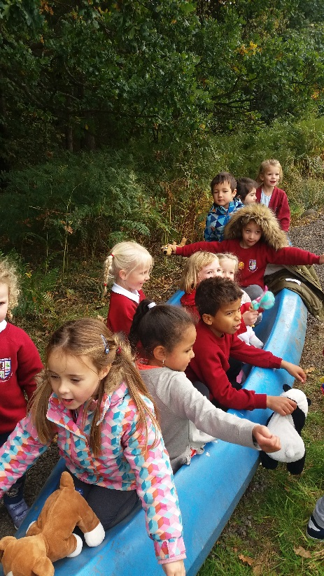

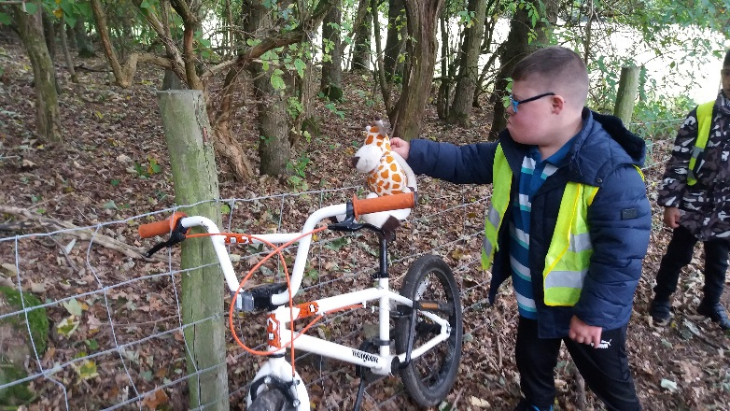

**Quotes from teachers:**

‘This is great, lots of our children don’t get the chance to play outdoors like this.’

‘Herd Farm is amazing, I can’t believe I didn’t know it was here!’

‘They will have never been in such a big space.’

‘I feel so lucky that we’ve got to come, will you be doing this again?’

‘It’s been amazing, can we come back tomorrow?’

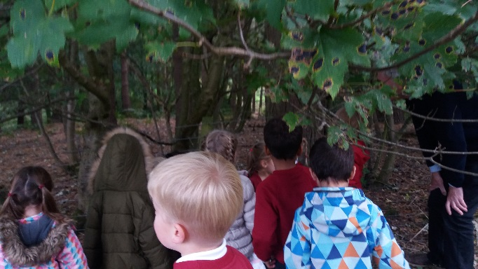

**Quotes from children:**

‘I can hear the leaves and crunching under my feet.’ ‘Teddy left these acorns here.’ ‘It’s like a green sky.’ ‘Tell teddy I’m coming.’ ‘There’s lots of space.’