**WHY?**

**1. We found an increasing number of children were coming into reception without the core strength to enable them to sit and hold a pencil effectively or sit still on the carpet. This detracted from their learning. We wanted to do something fun and different to the normal sport provision, which would also have an impact on their ability to focus and keep their bodies and minds calm.**

2. We have a cohort of children in school with complex needs including autism, dyspraxia, anger management issues and low self-esteem. **Reaching out to these children to influence their behaviours and impact on their overall happiness was something we wanted to address as a school.**

**HOW?**

We found out about the Tatty Bumpkin Rainbow Programme when Children Inspired by Yoga delivered a taster session at the Active Schools subject leader day.On coming back to school we talked to our Reception teachers about the benefits of the yoga sessions and decided that it would be an excellent use of our SSP money. The SLT were fully in support of this as it tied in nicely with our school development plan. Children Inspired by Yoga came in to do a taster session in July and we subsequently booked them in for the autumn term for our two Reception classes and a complex needs group. At a cost of £2040 for 12 weeks, which included a free 2-hour staff wellbeing twilight.

The feedback from both reception teachers and our SENCO and Learning Mentor was so fantastic that we have re-booked Yoga for the spring term and will add in a targeted Year 1/2 group also.

**Key Indicator**

**1:** The engagement of all pupils in regular physical activity – Chief Medical Officer Guidelines recommend that primary school children undertake at least 30 minutes of physical activity a day in school

**2:** The profile of PE and sport being raised across the school as a tool for whole school improvement

**3:** Increased confidence, knowledge and skills of all staff in teaching PE and sport

**4:** Broader experience of a range of sports and activities offered to all pupils

**5:** Increased participation in competitive sport

Cookridge Holy Trinity C of E Primary

Yoga sessions Autumn 2018



**Reception pupil’s quotes:**

‘We get to do dog poses and pass a banana around with our feet’

‘You can copy the teacher’

‘I like the fast bicycle, it was fun’

‘It makes your body feel really good and strong.’

‘When she gives us the eye mask, I feel like I’m at home sleeping in my bed with my teddy.’

**Year 3 pupil’s quote**

‘I felt angry inside at the start,

but now I feel calm and my body feels relaxed.’

**IMPACT**

**Teachers have reported that the children are able to concentrate for longer periods. On completion of the session they are calm and focussed. This overspills into the classroom.**

**The planning from Tatty Bumpkins is written with Early Learning Goals in mind, aiding communication and language.**

**For one hearing impaired child in Reception it has made a huge difference as they are now much more engaged in the lessons. We have taken elements of the sessions into our own lessons to further develop gross motor skills and core strength. The sessions have a multi-sensory approach, using music and lovely, interactive props to engage the children. The children often retell the story they’ve learnt in Yoga outside of the sessions. We’ve also seen an improvement in their ability to follow instructions and focus.**

**For one year 3 child with anger management issues it has made a really positive difference, during the course of an observed session he went from highly agitated and angry after a break time to being calm and relaxed at the end of the half hour session. His teacher has remarked how different he is on coming back to the classroom following the Yoga. He appears so much calmer and happier in himself. He is learning how to control his emotions and develop a sense of calm. The child spoke about how his emotions change from being angry to calm, ‘my body feels nice’.**

**For many of the complex needs group, teachers have reported overspill benefits – they look forward to the sessions. The one-to-one teaching assistants also join in the Yoga, which helps them bond with the pupils they work with.**

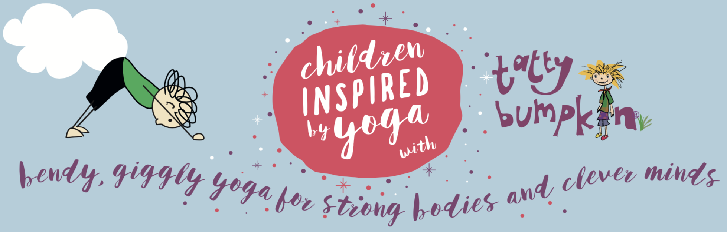[](https://www.google.co.uk/url?sa=i&rct=j&q=&esrc=s&source=images&cd=&cad=rja&uact=8&ved=2ahUKEwjP_-ysoLPeAhUE-qQKHaJoC94QjRx6BAgBEAU&url=https://www.astroexhibitions.co.uk/how-much-does-an-exhibition-stand-cost/&psig=AOvVaw1DFKLUd1deOiWe5BMh3nbC&ust=1541163640140755)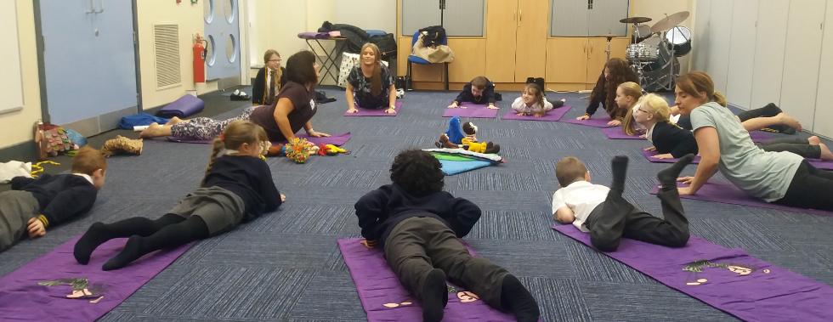 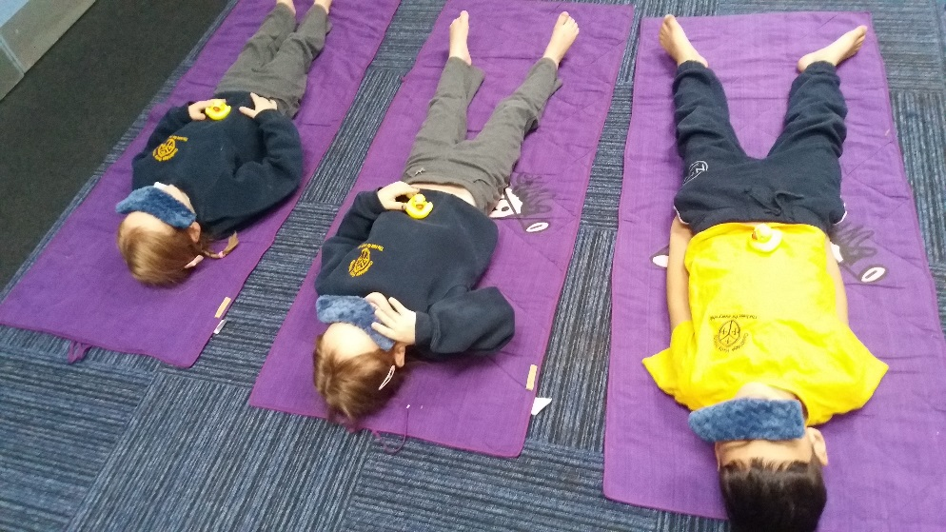

**For more information contact:**

[info@holytrinity.leeds.sch.uk](mailto:info@holytrinity.leeds.sch.uk)

wharfedale@tattybumpkin.com

Melissa Butterworth (PGCE) & Anna Dawson (BEd)

Focussing on essential development skills, we empower pupils with movement, mindfulness & relaxation strategies for learning and for life.

£2040 for 12 weeks of Wednesday mornings. A free staff wellbeing twilight was also included in this price.

**NEXT STEPS**

Targeting a behaviour group.

After Christmas Yr 1 and 2 Gross Motor Skills focus group to develop core strength and balance. We will also choose children who find focus and concentration a challenge.

Other teachers have got involved. They are using Cosmic Kids Yoga and Zen Den (both on YouTube) as a calming influence in their own classrooms.

Parents have been fully informed about the Yoga sessions with Reception and are given regular updates in their weekly newsletters and on the school website.

**One of the parents from the complex needs group actually commented that the sessions are having an impact on their daughter’s behaviour at home, they are delighted.**

**ENGAGING PARENTS**