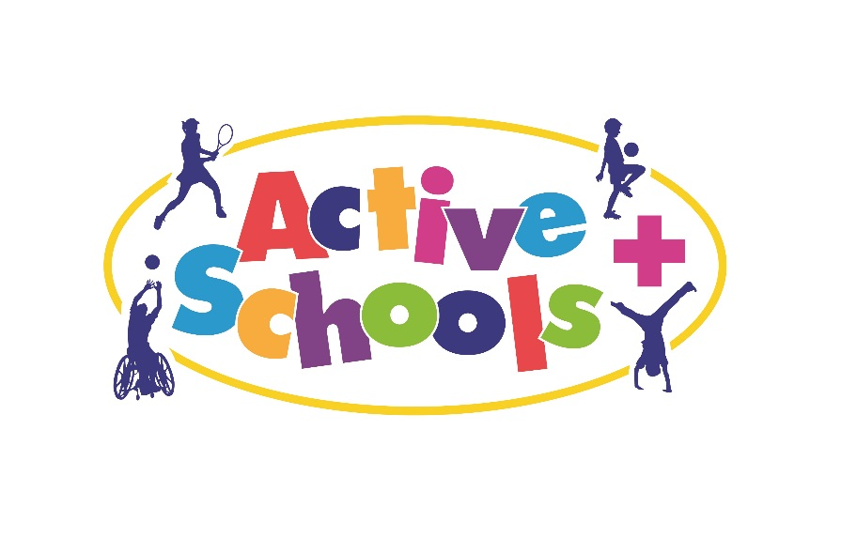
PLEASE NOTE THIS EVENT CAN ONLY BE ACCESSED BY SCHOOLS WHO ARE PART OF THE ACTIVE SCHOOLS PROGRAMME 18/19.

Active Schools She Rallies
Professional Development Course and Event
Friday 16th November 2018
1pm – 4pm
Tennis Centre
John Charles Centre for Sport

Dear colleague,
Following on from the success of She Rallies last year, we are delighted to announce a new date for this year for schools to be involved in our KS2 She Rallies Event and PD course for female teachers.

The PD course will include lots of great ideas for teaching girls in schools. Delegates will be asked to complete an action plan which will allow them to access a free kit bag worth around £300.

Whilst delegates receive the training, an event will be taking place on the adjoining courts. Therefore delegates attending the course will be expected to bring along a group of 10 KS2 girls who will be involved in this fun tennis event run by qualified coaches.

As an Active School, we would like to invite your school to be part of this event to be held at the John Charles Centre for Sport on Friday 16th November, 12.30 – 3.30pm

The vision of ‘She Rallies’ is to attract and retain more women and girls tennis in the UK by inspiring and empowering a female workforce to create more opportunities for women and girls in tennis. Read More

For more information on She Rallies please visit http://sherallies.com

Please note that this course is for female staff only.

Each school is invited to bring a maximum of 10 girls, although there may be the possibility to bring more, please email donna.russell@leeds.gov.uk if this is something that you would like to do.

At this stage, we would like to know if your school would like to participate in this PD / Event. Please confirm by 4.00pm on Wednesday 17th October by emailing donna.russell@leeds.gov.uk with:

School Name:
Contact Name and Details of delegate attending courses (if different to email):

We would like to bring ____KS2 girls (maximum of 10 / school)

After this date, we will email your school to confirm your place along with full details for the day.

If there are more schools than places available, schools will be chosen through a draw. The draw will take place, if necessary, on Wednesday 17 October 2018.

