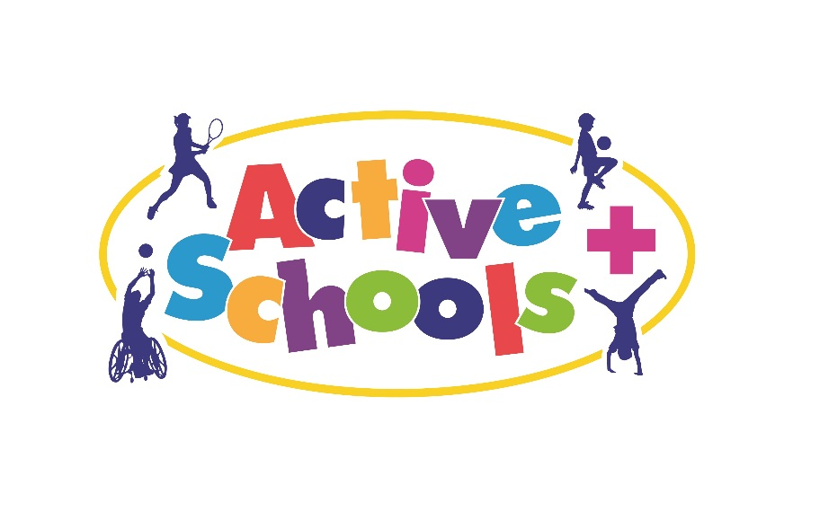
PLEASE NOTE THIS EVENT CAN ONLY BE ACCESSED BY SCHOOLS WHO ARE PART OF THE ACTIVE SCHOOLS PROGRAMME 18/19.

Active Schools
Early Years Explorers Event
Mon 1st Oct, Thurs 4th Oct 2018
Herd Farm

Dear colleague, we are delighted to announce a wonderful opportunity for schools to be involved in our first ever Early Years Explorers Event being run in partnership with Herd Farm.
The event will involve children in Foundation Stage having an opportunity to be part of an Active Schools Physical Activity Event. The event will run in 2 sessions as follows and schools will be allocated a morning or afternoon slot for their children to take part. This will be repeated on day 2 for a new cohort of schools.
Morning Session:
9.30am Arrival and Registration
10.00 – 11.30am Children will take part in activities (walk and explore)
11.30am Lunch – Teddy Bear Picnic
12.00 Return to school

Afternoon Session:
12.30pm Arrive, Registration and Lunch – Teddy Bear Picnic
1.20pm-2.50pm Children will take part in activities (walk and explore)
3.10pm Return to school

All the activities will be based around Herd farm and will include storytelling, challenges, teamwork and exploration.
The children will bring a packed lunch and will eat this with their Teddy Bears.
Each school is invited to bring up to 8 children. One person who has a current paediatric first aid certificate must accompany your group.

At this stage, we would like to know if your school would like to participate in the event. Please confirm by Friday 15th September by completing the details below and emailing donna.russell@leeds.gov.uk stating your preference in terms of the morning or afternoon session and day. After this date, we will write to your school to confirm your place and time slot, along with full details for the day.

If there are more schools than places available, schools will be chosen through a draw. The draw will take place, if necessary, on Friday 15th September.
Active Schools Early Years Explorers Event
School Name:

Contact Name and Details (if different to email):

Number of children:

Mode of Transport:

We would prefer the AM / PM* slot
We would prefer Monday / Thursday

*Please delete as appropriate
Kind Regards
Donna
Donna Russell
Active Schools Physical Education & Sport Consultant
Health and Wellbeing Service, Active Schools,
Children's Services, Adam's Court, Kildare Terrace, Whitehall Road, Leeds, LS12 1DB

Mobile: 07891203768
Admin: 0113 3785254

