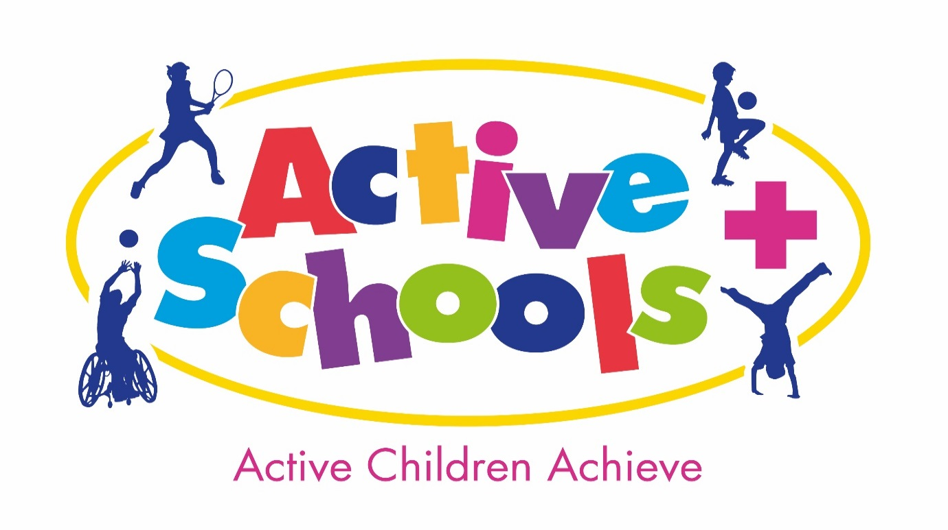Active Schools + Service
Head Teacher/Governor Bulletin
June 2018
I am very excited and privileged to be writing my first Head Teacher and Governor Bulletin and presenting our new Active Schools + logo. In these few pages I hope to bring Head Teachers, Senior Leaders and Governors up to date with the Physical Activity and the PE and Sport agenda, regardless of whether schools have signed up to the SLA this year. The Active Schools + Service delivers accountability for schools against the PE and Sport Premium Funding through:
- a comprehensive professional development programme
- advisory support
- pupil participation opportunities
- partnerships
- resources
- Innovative Projects.
Working with a range of partners, the service mission is to promote and develop, a sustainable system for Physical Activity, PE and Sport that enriches the lives of children and young people - something which has never been more important than in today’s climate.
Active Schools + Service SLA 2018/19 (April 2018 – March 2019)…
The service currently has 109 schools signed up to the SLA offer and we look forward to working with you over the year. If you have yet to buy the SLA offer, or would like more information, please go to www.leedsforlearning.co.uk
Keeping in touch over the year…
We are currently sending out fortnightly Primary PE Subject Leader Bulletins which go out to schools every other Monday and contain national updates, training opportunities, events, competition information as well as partner information.

News about what we have been doing…
Brownlee Triathlon 2018: Our Active School + year got off to a brilliant start with 1,972 (up by 160 from last year) children participating in 2 Brownlee Triathlon events. We captured the moment with these hashtag comments from the children: #fun # exhausted #thisgirlcan #lovedit #proud #swimbikerun #proudtobeyorkshire #wellgood #amazeballs #tri-fan
Overview of the June Subject Leader Day
We were delighted to welcome James Winterbottom from Wigan Child services who delivered a keynote speech on The Daily Mile and the success it has had within Wigan CC. A healthy debate ensued where delegates shared successes and limitations to their implementation. Given the latest National ambition for schools to adopt a daily active initiative, delegates left with fresh ideas for what this could look like in their school setting.

Shirley Lundstram from Leeds Dance Partnership shared the vision for Leeds to be an international centre of excellence in dance through the ‘Investing in the future’ 2017-2021 strategy. The Active schools + Service is looking to build bridges between schools of dance in the city and primary schools. An audit of dance was completed by subject leaders and will be used to inform this link going forward.

Dan Wilson reported on the legality of reporting of the Sport Premium funding and shared good practice examples.
Please remember that the deadline for publishing your information was April 4 2018. Following this date the information on your website must be as follows.
- the amount of premium received
- a full breakdown of how it has been spent (or will be spent)
- what impact the school has seen on pupils’ PE and sport participation and attainment
- how the improvements will be sustainable in the future
- how many pupils within their year 6 cohort can do each of the following: swim competently, confidently and proficiently over a distance of at least 25 meters, use a range of strokes effectively and perform safe self-rescue in different water-based situations.

Thank you to delegates from Immaculate Heart CPS, Yeadon Westfield and Westwood Primary who shared details of their good practice, making an impact with their Sport Premium spending, which was very well received by all delegates.

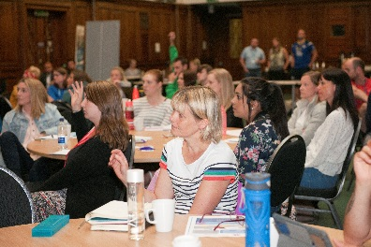
Following feedback from your subject leaders we would like to invite you as head teachers to accompany them to the morning session of our September Subject Leader Day.
The date and further information will be sent to you in due course.

News about what we are planning…
Active schools online – we have been busy developing our online site. Here you will find links to current news, resources to help meet the 30:30 directive and links to partner organisations. CLICK HERE
Destination Judo - An exciting opportunity for all Active schools + schools
Last year Destination @ British Judo worked with SGOs and SSPs to provide just under 3,000 free taster sessions to an estimated 82,000 children in English schools outside of Leeds.
In partnership with Active schools +, they are looking to replicate this success across Leeds. Providing opportunities for children to experience a broader range of sports and activities.
Each child will be offered a no cost taster session in school with a further free session in a local HUB location. By the end of the first year of the partnership, the aim will be to have 4 clubs open across the city, 1 in each area of the city, with scope for more should need dictate.
Marc Preston (6th Dan), who established and directs the Destination Judo programme, was Scotland’s most successful judo player of his generation, a medallist at world and commonwealth level and with a long list of judo related achievements. From there, he went on to coach the British Olympic team and establish his own judo school. Marc is the Vice-Chairman of and Director of Judo Scotland, and will present his vision for Leeds at the September Subject Leader Day.

Latest new and updates…
Primary schools across the country recently had the Primary PE and Sport Premium funding doubled by government - ushering in a 'once in a generation' opportunity to transform PE and school sport. (Simon Ward, Youth Sport Trust)

Sport Premium reporting: The Department for Education commissioned the Association for Physical Education and the Youth Sport Trust to create a national template which has been recently updated, to include swimming data. Head teachers, Governors and Subject Leaders will be able to use this simple reporting mechanism to ensure they are compliant.
Click HERE to download a PDF copy of the template.
Click HERE to download a Word copy of the template.
To support schools with their reporting, afPE has developed a useful exemplification document which covers all five of the key indicators.

Childhood Obesity plan: New measures to halve the number of obese children by 2030 have been announced by Health and Social Care Secretary Jeremy Hunt.
The plan promotes a new national ambition for every primary school to adopt a daily ‘active’ initiative, such as the Daily Mile. This is supported by £620,000 funding for Living Street’s Walk to School project, as well as £1 million to support the Department for Transport’s Bikeability cycling training programme, expected to fund an additional 25,000 training places. This in addition to high quality PE will contribute to pupils’ physical and emotional development which in turn can impact on academic standards

Resources:
A new toolkit of cross-curricular resources to help you cover physical activity in fun, easy and creative ways. Train Like a Jedi take-home packs will be arriving in schools between 18th June and 13th July – the pack will come out through the Fruit and Veg scheme. The programme includes Star Wars inspired activities to get your whole school enjoying physical activity at any point in the school day. Get started with the whole-school assembly PowerPoint or with new video footage featuring double Olympic gold taekwondo champion, Jade Jones, who will demonstrate a series of 12 moves that will help pupils master the ways of the Jedi.

For more information CLICK HERE

Health & Safety: EVOLVE
Please can we just remind schools that all risk assessments for Active School + events are available for you on Evolve under the Active Schools + tab? It is the responsibility of individual schools to have appropriate risk assessments in place for all activities they attend. Active Schools + will not send risk assessments direct to Schools. You should download sample risk assessments from Evolve for all Active Schools + events and amend them accordingly. The ‘Events’ risk assessment can be adapted to cover the vast majority of sites used, and for all multi skills activities. Your school may also add activity specific risk assessments if they feel it necessary. As always a Transport risk assessment will be required.
Save time completing Evolve forms by following this link
Guidance for Heads of PE re FIXTURES

There can be one EVOLVE entry per sport entered. There can be multiple venues listed and the add note function can be used to add any information not included on the form. The ratio should be the maximum and all the members of staff that could potentially lead the fixture could be entered as accompanying staff. The head of PE would be a suitable person to choose as the permanent leader for all the fixtures although s/he may not be the actual leader of that visit.
All potential dates should be entered and any further dates entered later. The visit entry will close 28 days after the last visit date so it may be prudent to enter one date towards the end of the year.

PGCE Primary PE Specialism
Both Leeds Beckett University and Leeds Trinity University are now offering the PGCE Primary PE Specialism course and are looking for schools in which to place their students. If you would be interested in having a student or finding out more about this, please let us know.
Professional Development to look out for…
Active Schools + & England Netball Hi 5 workshop
Date: 13th September, 4.00 – 7.00pm
Venue: Leeds Trinity University.
Cost: £25 affiliated, £35 non affiliated
For booking information, please contact: Natalie Mallinson
Email: n.mallinson@stmarysmenston.org

Subject Leader date
Date: September 2018 - date to be confirmed
Venue: to be confirmed

Head Teacher Wellbeing conference Friday 6th November
Wellbeing of staff is a key priority for Leeds City Council and we are aware of the serious effects that the stresses and pressures of work can have on the wellbeing of Heads, Senior Leaders and staff in schools. Leeds Council and Education supports invite you to take some time out attend a on Friday 16th November.
- Key note speeches from Chief Executives from LCC and Education Support.
- Presentations from 2 Headteachers about what Headspace has meant for them and what they’ve done in their schools to promote wellbeing.
- At least 3 Practical wellbeing workshops
- Presentations of what wellbeing help, support and services are available to Headteachers and their staff.
- A chance to network and visit the wellbeing services exhibition.
- Free lunch !!!!

Please book your free place CLICK HERE
To Do List:

- Ensure your school has signed up to the Active Schools SLA – Primary/SILC by going to www.leedsforlearning.co.uk

- Ensure your PE Subject Leader has completed the School Games Mark Application. The closing date is 14th September 2018

- Inform the Active Schools + service by emailing activeschools@leeds.gov.uk of any changes or pending changes in contact details for either yourself or your PE Subject Lead.

