Many schools find themselves in the position that they need to purchase swim noodles to access school swimming in line with Covid health and safety guidance. We hope this document will help illustrate the versatility of the ‘pool noodle’ and highlight that it is a worthy addition to your primary PE store cupboard long term.  Our top 10 uses of the noodle outside of swimming… | KS1 balance beams, try to tightrope walk across the noodle horizontally - side stepping. Extend by moving in a linear balance - one front in front of other along the noodle.  Develops coordination, balance and strength. | KS1 object control - take your noodle for a walk – control a ball with the noodle keeping it close. Move through gates to extend and challenge.
KS1 noodle balance - Balance on your head, balance on an outstretched arm or leg. Can you balance a noodle on your back on all 4’s and travel around the space? | KS1 Noodle tig – just like the name suggests. Use the noodle to tig class mates. Soft touch tig, when children are out set them a challenge before re-joining the game. | KS1 Noodles as boundaries We like the adapted game of air hockey – use the noodles as parallel boundaries, children lie on their stomachs and using a plastic floor marker push a soft ball towards their partner’s end line to score. Great for hand eye coordination, shoulder and core strength! Not to mention great fun
KS2 Ball Pass. Work in pairs to get the ball to and from each other only using 2 noodles to balance the ball. Tilt the noodles to move the ball, how many passes in 1 minute? Extension – try adding a throw up and catch again on the noodle.  Develops teamwork and hand eye coordination. | KS2 Loggers –teamwork and communication. A challenge for 3 people. 2 people hold 1 noodle like long skipping rope. In unison move noodle from behind, overhead of person3 to jump. Move forward to a finish line | KS2 Noodle balance – balance on the palm of your hand with noodle facing vertically. Challenge children to move around making small adjustments to maintain an upright noodle.
KS2 speed bounce – using the noodle as the centre line children jump sideways over with a two footed jump. Challenge the children to see how many jumps they can do in a set time. | KS2 Reflex test – hold the noodle vertically at bottom, release and catch. Begin with your dominant hand, then extend by using your non dominant hand. How close to the top can you catch it?  Group challenge: noodle swap. A vertical pass round a group of 3, add in a second noodle, then a third a great teamwork challenge. | 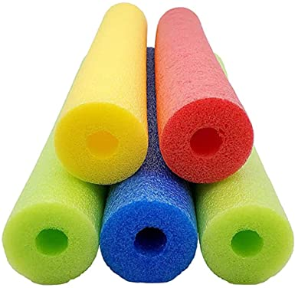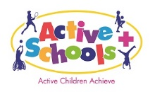  A quick internet search will offer lots more ideas.

