The Asthma Friendly Schools award was initiated to encourage schools to develop safe, healthy and inclusive environments for students with asthma. An Asthma Friendly School adopts the programme strategies to support the whole school community in understanding and managing asthma.
Benefits to becoming and Asthma Friendly school include:
- Improving asthma awareness and management in the school
- Improving support to students with asthma encouraging an inclusive environment
- Supporting responsibilities for the health, safety and wellbeing of students and staff
- Ensures the school is implementing current and best practice asthma management strategies
- Enables the school to promote its self-evaluate status to ensure that the community is aware of the school's commitment to Asthma Friendly strategies.

The flowchart below illustrates what is needed to become an Asthma Friendly School.

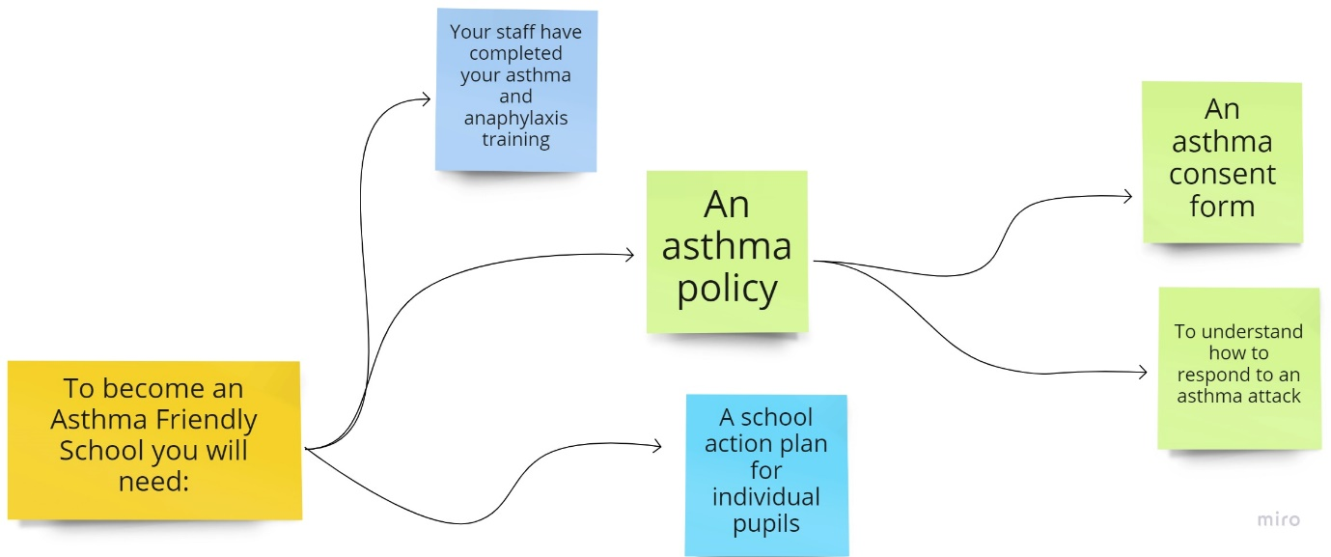

For further information on each of the elements, please return to the webpage and click on the individual headings.

